***Foundations of Earth Science, 8e* (Lutgens/Tarbuck/Tasa)**

**Chapter 1 Matter and Minerals**

1.1 Multiple-Choice Questions

1) Which of the following best defines the relationship between minerals and rocks?

A) A rock has an orderly, repetitive, geometrical, internal arrangement of minerals; a mineral is a lithified or consolidated aggregate of rocks.

B) A mineral consists of atoms arranged in a geometrically repetitive structure; in a rock, the atoms are randomly bonded without any geometric pattern.

C) In a mineral, atoms are bonded in a regular, repetitive, internal structure; a rock is a lithified or consolidated aggregate of mineral grains.

D) A rock consists of atoms bonded in a regular, geometrically predictable arrangement; a mineral is a consolidated aggregate of rock particles.

Answer: C

Diff: 1

Bloom's Taxonomy: Remembering/Understanding

Global Sci Out: G2, G7

Section: 1.1 Minerals: Building Blocks of Rocks

Focus/Concepts: 1.1

ESLI: 1.2 Earth scientists use a large variety of scientific principles to understand how our planet works.

2) All of the atoms making up any given element have the same number of ________.

A) electrons in the nucleus

B) protons in the nucleus

C) neutrons in the outer nuclear shell

D) electrons in the outermost valence shell

Answer: B

Diff: 1

Bloom's Taxonomy: Remembering/Understanding

Global Sci Out: G2

Section: 1.2 Atoms: Building Blocks of Minerals

Focus/Concepts: 1.2

ESLI: 1.2 Earth scientists use a large variety of scientific principles to understand how our planet works.

3) Atoms that have an electrical charge due to a gain or loss of electrons are called ________.

A) ions

B) isotopes

C) isochrons

D) neutrons

Answer: A

Diff: 1

Bloom's Taxonomy: Remembering/Understanding

Global Sci Out: G2

Section: 1.3 Why Atoms Bond

Focus/Concepts: 1.3

ESLI: 1.2 Earth scientists use a large variety of scientific principles to understand how our planet works.

4) When in contact with hydrochloric acid, which mineral gives off bubbles of carbon dioxide gas?

A) quartz

B) halite

C) calcite

D) fluorite

Answer: C

Diff: 1

Bloom's Taxonomy: Remembering/Understanding

Global Sci Out: G7

Section: 1.2 Atoms: Building Blocks of Minerals

Focus/Concepts: 1.2

ESLI: 1.3 Earth science investigations take many different forms.

5) The appearance or quality of light reflected from the surface of a mineral is known as ________.

A) cleavage

B) luster

C) specific gravity

D) streak

Answer: B

Diff: 1

Bloom's Taxonomy: Remembering/Understanding

Global Sci Out: G7

Section: 1.4 Properties of Minerals

Focus/Concepts: 1.4

ESLI: 1.3 Earth science investigations take many different forms.

6) Which common mineral is composed entirely of silicon and oxygen?

A) calcite

B) diamond

C) olivine

D) quartz

Answer: D

Diff: 1

Bloom's Taxonomy: Remembering/Understanding

Global Sci Out: G2

Section: 1.5 Mineral Groups

Focus/Concepts: 1.5

ESLI: 1.3 Earth science investigations take many different forms.

7) Which of the following silicate minerals is the most abundant in Earth's crust?

A) pyroxene

B) olivine

C) garnet

D) feldspars

Answer: D

Diff: 2

Bloom's Taxonomy: Remembering/Understanding

Global Sci Out: G7

Section: 1.5 Mineral Groups

Focus/Concepts: 1.5

ESLI: 4.6 Earth materials take many different forms as they cycle through the geosphere.

8) Which of the following minerals is a silicate (a mineral containing a silicon-bearing ion)?

A) hematite

B) feldspar

C) calcite

D) halite

Answer: B

Diff: 1

Bloom's Taxonomy: Remembering/Understanding

Global Sci Out: G7

Section: 1.5 Mineral Groups

Focus/Concepts: 1.5

ESLI: 4.6 Earth materials take many different forms as they cycle through the geosphere.

9) Which one of the following mineral groups exhibits a sheet-like silicate structure?

A) carbonates

B) pyroxenes

C) micas

D) feldspars

Answer: C

Diff: 1

Bloom's Taxonomy: Remembering/Understanding

Global Sci Out: G7

Section: 1.5 Mineral Groups

Focus/Concepts: 1.5

ESLI: 1.3 Earth science investigations take many different forms.

10) The ion at the center of a silicon—oxygen tetrahedron is surrounded by ________.

A) 4 oxygen ions

B) 6 oxygen ions

C) 4 sodium ions

D) 6 sodium ions

Answer: A

Diff: 1

Bloom's Taxonomy: Remembering/Understanding

Global Sci Out: G2

Section: 1.5 Mineral Groups

Focus/Concepts: 1.5

ESLI: 1.2 Earth scientists use a large variety of scientific principles to understand how our planet works.

11) The resistance of a mineral to scratching or abrasion is known as ________.

A) luster

B) cleavage

C) streak

D) hardness

Answer: D

Diff: 1

Bloom's Taxonomy: Remembering/Understanding

Global Sci Out: G2

Section: 1.4 Properties of Minerals

Focus/Concepts: 1.4

ESLI: 1.3 Earth science investigations take many different forms.

12) Imagine you are handed a mineral sample. It breaks with a conchoidal fracture but displays no cleavage. It does not react with hydrochloric acid, is a light pink color, and has a nonmetallic luster. It is harder than a streak plate, and has a specific gravity of 2.65. What mineral is it?

A) olivine

B) potassium feldspar

C) calcite

D) quartz

Answer: D

Diff: 2

Bloom's Taxonomy: Applying/Analyzing

Global Sci Out: G2, G7, G9

Section: 1.5 Mineral Groups

Focus/Concepts: 1.5

ESLI: 1.3 Earth science investigations take many different forms.

13) You are handed a sample of an unknown silicate mineral. Which two elements **must** it contain?

A) silicon and oxygen

B) iron and silicon

C) carbon and hydrogen

D) silicon and sodium

Answer: A

Diff: 2

Bloom's Taxonomy: Remembering/Understanding

Global Sci Out: G7

Section: 1.5 Mineral Groups

Focus/Concepts: 1.5

ESLI: 1.3 Earth science investigations take many different forms.

14) What element is the most abundant in Earth's crust by weight?

A) carbon

B) chlorine

C) oxygen

D) lead

Answer: C

Diff: 1

Bloom's Taxonomy: Remembering/Understanding

Global Sci Out: G7

Section: 1.5 Mineral Groups

Focus/Concepts: 1.5

ESLI: 4.6 Earth materials take many different forms as they cycle through the geosphere.

15) Which of the following is a silicate mineral with a single-chained structure?

A) olivine

B) pyroxene

C) amphibole

D) mica

Answer: B

Diff: 1

Bloom's Taxonomy: Remembering/Understanding

Global Sci Out: G7

Section: 1.5 Mineral Groups

Focus/Concepts: 1.5

ESLI: 1.3 Earth science investigations take many different forms.

16) Due to the arrangement of weaker bonds in their crystal lattice, the tendency of certain minerals to break along smooth, parallel planes is known as ________.

A) streak

B) cleavage

C) luster

D) crystal habit

Answer: B

Diff: 1

Bloom's Taxonomy: Remembering/Understanding

Global Sci Out: G3

Section: 1.4 Properties of Minerals

Focus/Concepts: 1.4

ESLI: 1.3 Earth science investigations take many different forms.

17) An atom's mass number is 13 and its atomic number is 6. How many neutrons are in its nucleus?

A) 19

B) 13

C) 7

D) 6

Answer: C

Diff: 2

Bloom's Taxonomy: Remembering/Understanding

Global Sci Out: G2, G4

Section: 1.5 Mineral Groups

Focus/Concepts: 1.5

ESLI: 1.3 Earth science investigations take many different forms.

18) Three of the following **are** true for minerals. Which one of the following is **not** true for minerals?

A) They have a specific, predictable chemical composition.

B) They have an orderly internal crystalline structure.

C) They can be identified by characteristic physical properties.

D) They can be a liquid, solid, or gas.

Answer: D

Diff: 1

Bloom's Taxonomy: Remembering/Understanding

Global Sci Out: G7

Section: 1.1 Minerals: Building Blocks of Rocks

Focus/Concepts: 1.1

ESLI: 1.3 Earth science investigations take many different forms.

19) Which the following are the positively charged particles in an atom's nucleus?

A) protons

B) neutrons

C) ions

D) electrons

Answer: A

Diff: 1

Bloom's Taxonomy: Remembering/Understanding

Global Sci Out: G7

Section: 1.2 Atoms: Building Blocks of Minerals

Focus/Concepts: 1.2

ESLI: 1.3 Earth science investigations take many different forms.

20) Which of the following has the highest specific gravity?

A) styrofoam

B) water

C) halite

D) gold

Answer: D

Diff: 1

Bloom's Taxonomy: Remembering/Understanding

Global Sci Out: G7

Section: 1.4 Properties of Minerals

Focus/Concepts: 1.4

ESLI: 1.3 Earth science investigations take many different forms.

21) Which of the following properties would be least useful for identifying a sample of calcite?

A) reaction to hydrochloric acid

B) three planes of cleavage

C) white color

D) hardness of 3 on the Mohs scale

Answer: C

Diff: 2

Bloom's Taxonomy: Applying/Analyzing

Global Sci Out: G2, G9

Section: 1.4 Properties of Minerals

Focus/Concepts: 1.4

ESLI: 1.3 Earth science investigations take many different forms.

22) A cubic centimeter each of quartz, olivine, and native gold weighs 2.5, 3.0, and 19.8 grams, respectively. These weights indicate that *________*.

A) gold has a higher density and specific gravity than quartz and olivine

B) olivine melts at a higher temperature than either gold or quartz

C) gold is 6 to 7 times harder than olivine and quartz

D) gold and olivine qualify as silicates, but quartz would not

Answer: A

Diff: 3

Bloom's Taxonomy: Evaluating/Creating

Global Sci Out: G2, G4

Section: 1.4 Properties of Minerals

Focus/Concepts: 1.4

ESLI: 1.3 Earth science investigations take many different forms.

23) Which of the following silicate minerals forms from single tetrahedra?

A) biotite

B) quartz

C) potassium feldspar

D) olivine

Answer: D

Diff: 1

Bloom's Taxonomy: Remembering/Understanding

Global Sci Out: G7

Section: 1.5 Mineral Groups

Focus/Concepts: 1.5

ESLI: 1.3 Earth science investigations take many different forms.

24) If a mineral has a specific gravity of 3, it must be ________ times as dense as water.

A) 1

B) 2

C) 3

D) 4

Answer: C

Diff: 2

Bloom's Taxonomy: Remembering/Understanding

Global Sci Out: G2, G4

Section: 1.4 Properties of Minerals

Focus/Concepts: 1.4

ESLI: 1.3 Earth science investigations take many different forms.

25) ________ exhibits a conchoidal fracture.

A) Quartz

B) Halite

C) Gypsum

D) Calcite

Answer: A

Diff: 1

Bloom's Taxonomy: Remembering/Understanding

Global Sci Out: G7

Section: 1.4 Properties of Minerals

Focus/Concepts: 1.4

ESLI: 1.3 Earth science investigations take many different forms.

26) The ________ mineral group reacts to hydrochloric acid.

A) silicate

B) carbonate

C) halide

D) oxide

Answer: B

Diff: 2

Bloom's Taxonomy: Remembering/Understanding

Global Sci Out: G7

Section: 1.4 Properties of Minerals

Focus/Concepts: 1.4

ESLI: 1.3 Earth science investigations take many different forms.

27) An aggregate of one or more minerals is called a(n) ________.

A) atom

B) compound

C) ionic bond

D) rock

Answer: D

Diff: 1

Bloom's Taxonomy: Remembering/Understanding

Global Sci Out: G7

Section: 1.1 Minerals: Building Blocks of Rocks

Focus/Concepts: 1.1

ESLI: 4.6 Earth materials take many different forms as they cycle through the geosphere.

28) Biotite has which of the following types of cleavage?

A) cleavage in one direction

B) two directions at 90° angles

C) three directions at 90° angles

D) cleavage in four directions

Answer: A

Diff: 1

Bloom's Taxonomy: Remembering/Understanding

Global Sci Out: G7

Section: 1.4 Properties of Minerals

Focus/Concepts: 1.4

ESLI: 1.3 Earth science investigations take many different forms.

29) A mineral's resistance to breaking, bending, or cutting is defined as:

A) Fracture

B) Cleavage

C) Tenacity

D) Specific gravity

Answer: C

Diff: 1

Bloom's Taxonomy: Remembering/Understanding

Global Sci Out: G7

Section: 1.4 Properties of Minerals

Focus/Concepts: 1.4

ESLI: 1.3 Earth science investigations take many different forms.

30) ________ bonding is the sharing of valence atoms between a pair of atoms.

A) Ionic

B) Metallic

C) Hydrogen

D) Covalent

Answer: D

Diff: 1

Bloom's Taxonomy: Remembering/Understanding

Global Sci Out: G7

Section: 1.3 Why Atoms Bond

Focus/Concepts: 1.3

ESLI: 1.3 Earth science investigations take many different forms.

31) The most common group of minerals in Earth's crust are the ________.

A) oxides

B) carbonates

C) native metals

D) silicates

Answer: C

Diff: 1

Bloom's Taxonomy: Remembering/Understanding

Global Sci Out: G7

Section: 1.5 Mineral Groups

Focus/Concepts: 1.5

ESLI: 1.3 Earth science investigations take many different forms.

32) Feldspar minerals can look very similar to each other, what would you look for to differentiate plagioclase feldspar from potassium feldspar?

A) striations on plagioclase feldspar

B) cleavage angles

C) hardness

D) crystal habit

Answer: A

Diff: 2

Bloom's Taxonomy: Applying/Analyzing

Global Sci Out: G7

Section: 1.4 Properties of Minerals

Focus/Concepts: 1.4

ESLI: 4.6 Earth materials take many different forms as they cycle through the geosphere.

33) If an atom has an equal number of electrons and protons, it would be considered ________.

A) electrically neutral

B) electrically positive

C) electrically negative

D) metallic

Answer: A

Diff: 1

Bloom's Taxonomy: Applying/Analyzing

Global Sci Out: G2, G7

Section: 1.3 Why Atoms Bond

Focus/Concepts: 1.3

ESLI: 1.3 Earth science investigations take many different forms.

34) Which of the following elements has the most valance electrons in its outermost shell?

A) carbon

B) nitrogen

C) oxygen

D) helium

Answer: C

Diff: 1

Bloom's Taxonomy: Remembering/Understanding

Global Sci Out: G2

Section: 1.2 Atoms: Building Blocks of Minerals

Focus/Concepts: 1.2

ESLI: 1.3 Earth science investigations take many different forms.

35) The ability of a mineral to transmit both light and an image in the mineral is described as ________.

A) opaque

B) transparent

C) translucent

D) cloudy

Answer: B

Diff: 1

Bloom's Taxonomy: Remembering/Understanding

Global Sci Out: G7

Section: 1.4 Properties of Minerals

Focus/Concepts: 1.4

ESLI: 1.3 Earth science investigations take many different forms.

36) The terms *bladed, fibrous, cubic,* and *platy* describe ________.

A) tenacity

B) mineral strength

C) crystal habit

D) density

Answer: C

Diff: 1

Bloom's Taxonomy: Remembering/Understanding

Global Sci Out: G1

Section: 1.4 Properties of Minerals

Focus/Concepts: 1.4

ESLI: 1.3 Earth science investigations take many different forms.

37) ________ is the study of minerals.

A) Paleontology

B) Mineralogy

C) Petrology

D) Tenacity

Answer: B

Diff: 1

Bloom's Taxonomy: Remembering/Understanding

Global Sci Out: G1

Section: 1.1 Minerals: Building Blocks of Rocks

Focus/Concepts: 1.1

ESLI: 1.3 Earth science investigations take many different forms.

38) Which of the following minerals comprises just one element?

A) diamond

B) halite

C) quartz

D) talc

Answer: A

Diff: 1

Bloom's Taxonomy: Remembering/Understanding

Global Sci Out: G7

Section: 1.5 Mineral Groups

Focus/Concepts: 1.5

ESLI: 4.6 Earth materials take many different forms as they cycle through the geosphere.

39) ________ is the powdered form of the mineral.

A) Density

B) Streak

C) Hardness

D) Crystal habit

Answer: B

Diff: 1

Bloom's Taxonomy: Remembering/Understanding

Global Sci Out: G7

Section: 1.4 Properties of Minerals

Focus/Concepts: 1.4

ESLI: 1.3 Earth science investigations take many different forms.

40) Limestone is most similar to the mineral ________.

A) quartz

B) gypsum

C) halite

D) calcite

Answer: D

Diff: 1

Bloom's Taxonomy: Remembering/Understanding

Global Sci Out: G7

Section: 1.1 Minerals: Building Blocks of Rocks

Focus/Concepts: 1.1

ESLI: 4.6 Earth materials take many different forms as they cycle through the geosphere.

41) Which of the following minerals would best be utilized for extracted iron to make steel?

A) hematite

B) dolomite

C) quartz

D) talc

Answer: A

Diff: 1

Bloom's Taxonomy: Remembering/Understanding

Global Sci Out: G2, G5, G7

Section: 1.5 Mineral Groups

Focus/Concepts: 1.5

ESLI: 4.6 Earth materials take many different forms as they cycle through the geosphere.

42) ________ is the softest mineral and ________ is the hardest mineral on Mohs scale.

A) Talc; topaz

B) Gypsum; quartz

C) Talc; diamond

D) Gypsum; diamond

Answer: C

Diff: 1

Bloom's Taxonomy: Remembering/Understanding

Global Sci Out: G7

Section: 1.4 Properties of Minerals

Focus/Concepts: 1.4

ESLI: 1.3 Earth science investigations take many different forms.

43) Which of the following minerals has a metallic luster?

A) quartz

B) galena

C) diamond

D) halite

Answer: B

Diff: 1

Bloom's Taxonomy: Remembering/Understanding

Global Sci Out: G2

Section: 1.4 Properties of Minerals

Focus/Concepts: 1.4

ESLI: 1.3 Earth science investigations take many different forms.

44) Most silicate minerals form from ________.

A) earthquakes

B) meteorite impacts

C) erosional processes

D) molten rock

Answer: D

Diff: 1

Bloom's Taxonomy: Remembering/Understanding

Global Sci Out: G2, G7

Section: 1.5 Mineral Groups

Focus/Concepts: 1.5

ESLI: 4.6 Earth materials take many different forms as they cycle through the geosphere.

1.2 Matching Questions

***Match the following items with the correct descriptions.***

A) a mineral consisting of a poisonous gas ionically bonded to an extremely reactive metal.

B) a mineral in the carbonate family; showing three planes of cleavage and a fizzing reaction to hydrochloric acid.

C) a silicate mineral which has silicon-oxygen tetrahedra bonded in single-chained formation along with iron or magnesium atoms.

D) a rock composed of nonmineral matter.

E) an item that is solid like a mineral, has definite chemical composition, and shows distinctive physical properties, but does not have an orderly crystalline structure.

F) silicate mineral consisting solely of silicon and oxygen, with silicon-oxygen tetrahedra bonded in a complex three-dimensional network.

G) a mineral made of oxidized hydrogen.

H) an item that is solid like a mineral, has definite chemical composition, and shows distinctive physical properties, but is not naturally occurring.

1) ice

Diff: 3

Bloom's Taxonomy: Evaluating/Creating

Global Sci Out: G7

Section: 1.5 Mineral Groups

Focus/Concepts: 1.5

ESLI: 1.3 Earth science investigations take many different forms.

2) dinner plate

Diff: 3

Bloom's Taxonomy: Evaluating/Creating

Global Sci Out: G7

Section: 1.5 Mineral Groups

Focus/Concepts: 1.5

ESLI: 1.3 Earth science investigations take many different forms.

3) quartz

Diff: 3

Bloom's Taxonomy: Evaluating/Creating

Global Sci Out: G7

Section: 1.5 Mineral Groups

Focus/Concepts: 1.5

ESLI: 1.3 Earth science investigations take many different forms.

4) glass

Diff: 3

Bloom's Taxonomy: Evaluating/Creating

Global Sci Out: G7

Section: 1.5 Mineral Groups

Focus/Concepts: 1.5

ESLI: 1.3 Earth science investigations take many different forms.

5) halite

Diff: 3

Bloom's Taxonomy: Evaluating/Creating

Global Sci Out: G7

Section: 1.5 Mineral Groups

Focus/Concepts: 1.5

ESLI: 1.3 Earth science investigations take many different forms.

6) coal

Diff: 3

Bloom's Taxonomy: Evaluating/Creating

Global Sci Out: G7

Section: 1.5 Mineral Groups

Focus/Concepts: 1.5

ESLI: 1.3 Earth science investigations take many different forms.

7) calcite

Diff: 3

Bloom's Taxonomy: Evaluating/Creating

Global Sci Out: G7

Section: 1.5 Mineral Groups

Focus/Concepts: 1.5

ESLI: 1.3 Earth science investigations take many different forms.

8) pyroxene

Diff: 3

Bloom's Taxonomy: Evaluating/Creating

Global Sci Out: G7

Section: 1.5 Mineral Groups

Focus/Concepts: 1.5

ESLI: 1.3 Earth science investigations take many different forms.

Answers: 1) G 2) H 3) F 4) E 5) A 6) D 7) B 8) C

***Match the chemical bond with the correct definition.***

A) sharing of one or more valence electrons between a pair of atoms.

B) valence electrons are free to move from one atom to another so all atoms share the available valence electrons.

C) one atom gives up one or more valence electrons to another atom to form ions.

9) Metallic Bond

Diff: 3

Bloom's Taxonomy: Applying/Analyzing

Global Sci Out: G7

Section: 1.3 Why Atoms Bond

Focus/Concepts: 1.3

ESLI: 1.2 Earth scientists use a large variety of scientific principles to understand how our planet works.

10) Ionic Bond

Diff: 3

Bloom's Taxonomy: Applying/Analyzing

Global Sci Out: G7

Section: 1.3 Why Atoms Bond

Focus/Concepts: 1.3

ESLI: 1.2 Earth scientists use a large variety of scientific principles to understand how our planet works.

11) Covalent Bond

Diff: 3

Bloom's Taxonomy: Applying/Analyzing

Global Sci Out: G7

Section: 1.3 Why Atoms Bond

Focus/Concepts: 1.3

ESLI: 1.2 Earth scientists use a large variety of scientific principles to understand how our planet works.

Answers: 9) B 10) C 11) A

***Match the directional cleavage with the correct mineral.***

A) cleavage in three directions at 90° angles.

B) cleavage in two directions at 90° angles.

C) cleavage in one direction.

D) cleavage in four directions.

E) cleavage in three directions not at 90° angles.

F) cleavage in two directions not at 90° angles.

12) Fluorite

Diff: 3

Bloom's Taxonomy: Remembering/Understanding

Global Sci Out: G7

Section: 1.4 Properties of Minerals

Focus/Concepts: 1.4

ESLI: 1.3 Earth science investigations take many different forms.

13) Calcite

Diff: 3

Bloom's Taxonomy: Remembering/Understanding

Global Sci Out: G7

Section: 1.4 Properties of Minerals

Focus/Concepts: 1.4

ESLI: 1.3 Earth science investigations take many different forms.

14) Halite

Diff: 3

Bloom's Taxonomy: Remembering/Understanding

Global Sci Out: G7

Section: 1.4 Properties of Minerals

Focus/Concepts: 1.4

ESLI: 1.3 Earth science investigations take many different forms.

15) Hornblende

Diff: 3

Bloom's Taxonomy: Remembering/Understanding

Global Sci Out: G7

Section: 1.4 Properties of Minerals

Focus/Concepts: 1.4

ESLI: 1.3 Earth science investigations take many different forms.

16) Feldspar

Diff: 3

Bloom's Taxonomy: Remembering/Understanding

Global Sci Out: G7

Section: 1.4 Properties of Minerals

Focus/Concepts: 1.4

ESLI: 1.3 Earth science investigations take many different forms.

17) Muscovite

Diff: 3

Bloom's Taxonomy: Remembering/Understanding

Global Sci Out: G7

Section: 1.4 Properties of Minerals

Focus/Concepts: 1.4

ESLI: 1.3 Earth science investigations take many different forms.

Answers: 12) D 13) E 14) A 15) F 16) B 17) C

1.3 Essay Questions

1) Which elements are most common in the Earth's crust? What sorts of minerals (*i.e*., specific families) result from these particularly common elements? What sorts of rocks are most common in the crust as a result?

Answer: The most common elements are oxygen, silicon, aluminum, sodium, calcium, potassium and magnesium. The most common minerals that result from these elements are silicate minerals, including olivines, pyroxenes, amphiboles, micas, feldspars, and quartz. As a consequence, rocks made of these minerals, such as basalt, granite, schist, and quartz sandstone, are very common in the crust.

Diff: 3

Bloom's Taxonomy: Evaluating/Creating

Global Sci Out: G2, G7

Section: 1.5 Mineral Groups

Focus/Concepts: 1.5

ESLI: 4.6 Earth materials take many different forms as they cycle through the geosphere.

2) Describe in detail the relationship between elements, minerals, and rocks. Give a specific example of a specific element that is included in a specific mineral that is included in a specific rock.

Answer: Elements make up minerals, and minerals make up rocks. Answers will vary for the second part, but a correct answer might point out that iron and oxygen are elements. These elements may bond to form magnetite, and magnetite is a mineral that may be incorporated into a rock such as a sandstone.

Diff: 3

Bloom's Taxonomy: Evaluating/Creating

Global Sci Out: G2, G7

Section: 1.5 Mineral Groups

Focus/Concepts: 1.5

ESLI: 4.6 Earth materials take many different forms as they cycle through the geosphere.

3) Compare and contrast the light silicate minerals and dark silicate minerals, and give examples of each.

Answer: Both are silicate minerals, dominated by the elements silicon and oxygen, arranged in the silicon-oxygen tetrahedron. Light silicates tend to have larger amounts of sharing between their silicon-oxygen tetrahedral, while dark silicates tend to have less sharing (more oxygen atoms for every atom of silicon. Light silicates tend to include sodium and potassium in their crystal structure, while dark silicates tend to include magnesium, iron, or calcium.

Diff: 2

Bloom's Taxonomy: Evaluating/Creating

Global Sci Out: G7

Section: 1.5 Mineral Groups

Focus/Concepts: 1.5

ESLI: 1.3 Earth science investigations take many different forms.

4) What is the octet rule? Describe how it explains the behavior of atoms in forming ionic and covalent bonds.

Answer: The octet rule is the generalization that atoms tend to gain, lose, or share electrons until they are surrounded by eight valence electrons. Although there are exceptions to the octet rule, it is a useful rule of thumb for understanding chemical bonding. It is because of the octet rule that two atoms of hydrogen will share their valence electrons in a covalent bond, and it also explains why sodium will give up an electron from its outer shell to a chlorine atom. The sodium thus goes from have one of eight valence electrons positions occupied to dropping down a valence level, gaining a positive charge, and having a "full eight" electrons in its new, lower valence level. The chlorine, in contrast, gains an electron to add to its pre-bonding seven electrons in its outer valence shell and also gain a full complement of eight. But that extra electron brings with it a negative charge, so chlorine is now an anion. Because opposites attract, the sodium cation and the negatively-charged chlorine are now bonded together into the ionic compound known as halite, or table salt.

Diff: 1

Bloom's Taxonomy: Evaluating/Creating

Global Sci Out: G7, G8

Section: 1.3 Why Atoms Bond

Focus/Concepts: 1.3

ESLI: 1.3 Earth science investigations take many different forms.

5) Quartz has a specific gravity of about 2.65. A 5-gallon bucket of water weighs 40 pounds. How much would a 5-gallon volume of solid quartz weigh?

Answer: It would weigh 106 pounds, because specific gravity is the ratio of a mineral's density to the density of water, which is 1.0 gram per cubic centimeter. So 5 gallons of quartz would weigh 2.65 times as much as 5 gallons of water. 40 times 2.65 is 106.

Diff: 2

Bloom's Taxonomy: Evaluating/Creating

Global Sci Out: G4

Section: 1.4 Properties of Minerals

Focus/Concepts: 1.4

ESLI: 1.2 Earth scientists use a large variety of scientific principles to understand how our planet works.

6) Describe the characteristics a substance must possess in order to qualify as a mineral, and then describe which of the following cannot be minerals, listing a specific reason for each.

a. Gold nugget

b. Seawater

c. Quartz

d. Cubic zirconia

e. Obsidian

f. Ruby

g. Glacial ice

h. Amber

Answer: Minerals are (1) naturally occurring (2) inorganic (3) solids that (4) possess an orderly crystalline structure and (5) a characteristic chemical composition. Gold is a mineral; seawater isn't because it isn't solid; quartz is; cubic zirconia isn't because it's not naturally occurring; obsidian isn't because it lacks an orderly crystalline structure; ruby is; glacial ice is; and amber is not because it lacks an orderly crystalline structure.

Diff: 2

Bloom's Taxonomy: Remembering/Understanding, Evaluating/Creating

Global Sci Out: G7

Section: 1.2 Atoms: Building Blocks of Minerals

Focus/Concepts: 1.2

ESLI: 1.3 Earth science investigations take many different forms.

7) What steps would you take in order to identify a mineral by its physical properties?

Answer: Test the hardness against substances/objects of known hardness; search for the number of cleavage planes and their orientation relative to one another. Identify the luster. Attempt to streak the mineral against a ceramic plate. Drop hydrochloric acid on it. See if it's magnetic. Compare all of these criteria to known properties for minerals, perhaps from my lab manual.

Diff: 2

Bloom's Taxonomy: Evaluating/Creating

Global Sci Out: G7, G9

Section: 1.4 Properties of Minerals

Focus/Concepts: 1.4

ESLI: 1.3 Earth science investigations take many different forms.

8) Calcite, halite, gypsum, and quartz are all light colored minerals with a similar appearance; however each mineral has a diagnostic property that makes it distinguishable from the others. Discuss in detail how you could easily identify these minerals.

Answer: Calcite reacts with acid and has three cleavage angles at non right angles.

Halite is salty with cleavage planes three directions of cleavage at right angles.

Gypsum is very soft, can be scratched with your fingernail. Quartz has a conchoidal fracture and will scratch glass.

Diff: 3

Bloom's Taxonomy: Evaluating/Creating

Global Sci Out: G7, G9

Section: 1.5 Mineral Groups

Focus/Concepts: 1.5

ESLI: 1.3 Earth science investigations take many different forms.

9) Ice and water both comprise H2O, yet water is not considered a mineral. Explain why ice is considered a mineral yet water is not.

Answer: Liquid water does not fit the criterion of being a solid substance.

Diff: 2

Bloom's Taxonomy: Evaluating/Creating

Global Sci Out: G7, G8

Section: 1.1 Minerals: Building Blocks of Rocks

Focus/Concepts: 1.1

ESLI: 1.3 Earth science investigations take many different forms.

10) Quartz often occurs naturally in a variety of colors and consequently is often misidentified or confused with other minerals. Explain why quartz may crystallize in a variety of colors despite having the same chemical formula.

Answer: Impurities in the crystal structure of quartz allow for multiple colors to form but do not alter the chemical formula.

Diff: 1

Bloom's Taxonomy: Evaluating/Creating

Global Sci Out: G7

Section: 1.4 Properties of Minerals

Focus/Concepts: 1.4

ESLI: 4.6 Earth materials take many different forms as they cycle through the geosphere.

1.4 Visual Questions

1) How many cleavage directions does this mineral specimen display?

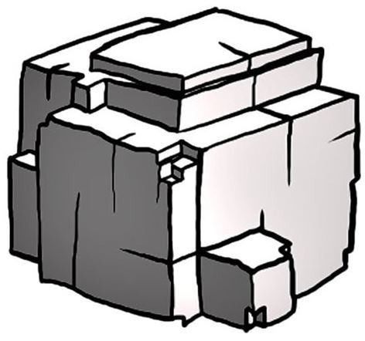

A) 1

B) 2

C) 3

D) 4

Answer: C

Diff: 2

Bloom's Taxonomy: Applying/Analyzing

Global Sci Out: G2

Section: 1.4 Properties of Minerals

Focus/Concepts: 1.4

ESLI: 1.2 Earth scientists use a large variety of scientific principles to understand how our planet works.

2) Both of the samples pictured here are examples of the mineral pyrite. The physical property that sets them apart is ________.

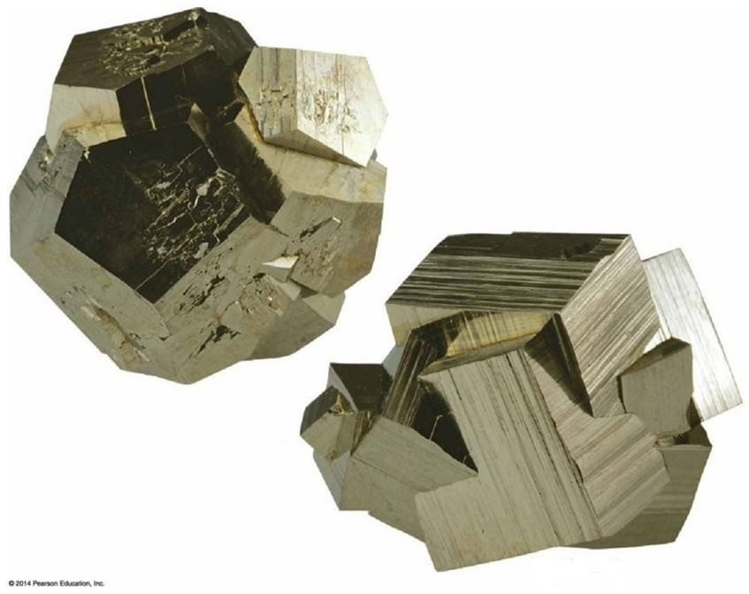

A) reaction to hydrochloric acid

B) crystal habit

C) streak

D) specific gravity

Answer: B

Diff: 2

Bloom's Taxonomy: Applying/Analyzing

Global Sci Out: G7, G9

Section: 1.4 Properties of Minerals

Focus/Concepts: 1.4

ESLI: 1.2 Earth scientists use a large variety of scientific principles to understand how our planet works.

3) Use the accompanying figure of the Mohs scale of hardness to answer this question. If you have a mineral sample that is capable of scratching a penny but is scratched by a wire nail, its hardness must be ________.

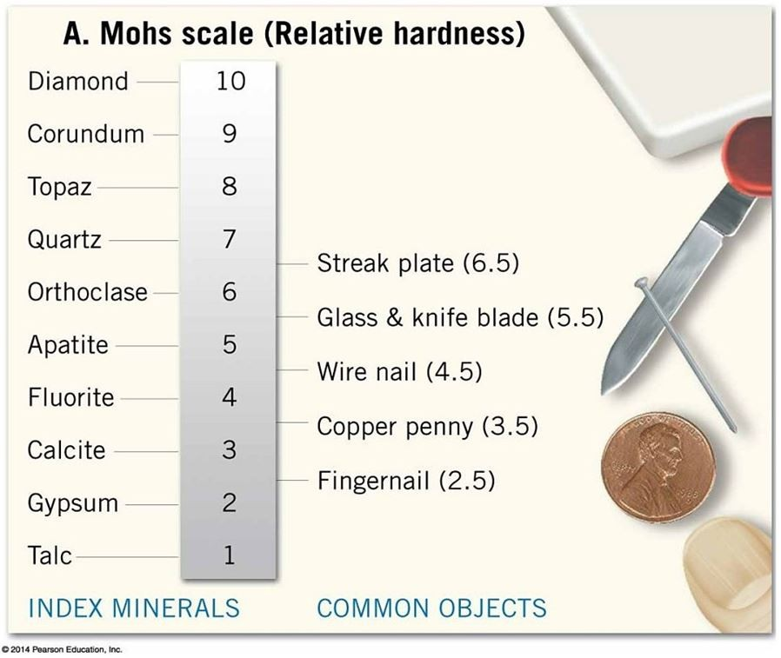

A) less than 3.5

B) between 3.5 and 4.5

C) greater than 4.5

D) less than 2.5

Answer: B

Diff: 2

Bloom's Taxonomy: Applying/Analyzing

Global Sci Out: G3

Section: 1.4 Properties of Minerals

Focus/Concepts: 1.4

ESLI: 1.3 Earth science investigations take many different forms.

4) Label each of the five atoms in this silicon-oxygen tetrahedron.

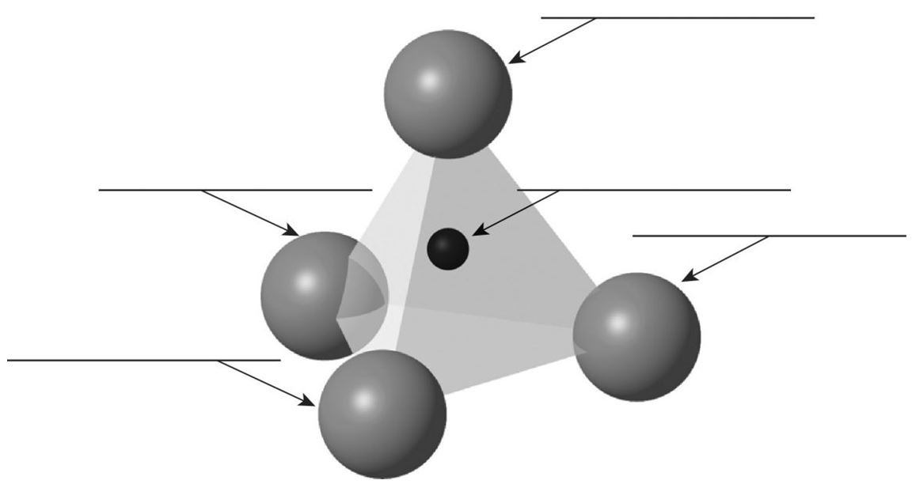

Answer:

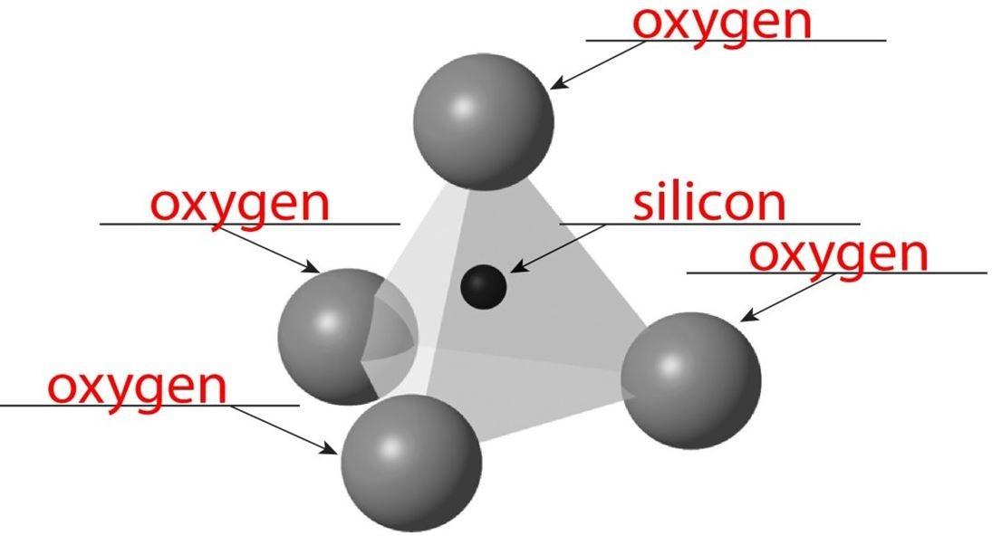

Diff: 2

Bloom's Taxonomy: Applying/Analyzing

Global Sci Out: G2

Section: 1.4 Properties of Minerals

Focus/Concepts: 1.4

ESLI: 1.3 Earth science investigations take many different forms.